University of Ontario Institute of Technology

Faculty of Business & IT

**Final Exam**

***INFR 1020U: Essential Math for Games 1***

*Fall 2017*

Last Name:_______________________________

First Name:_______________________________

Student ID:_______________________________

**Instructions**:

* Complete the ABOVE section before starting the exam
* Read ALL questions first
* Write ALL of your answers in the provided Exam Booklet
* You are allowed 1 x 8.5”x11” (letter) handwritten formula sheet
* You may use a scientific calculator (not graphing)
* Please complete your exam using a Blue or Black Pen
* Show ALL of your work for ALL questions
* Please write legibly, if I cannot read it I cannot mark it…. ;)

Total: /87

**Part 1: Fundamentals [32 marks]***(please see the data sheet at the end for the values of these vectors/matrices)*

1. 
2. 
3. 
4. Scale  so its length is 4 units
5. 
6. 
7. Project  onto 
8. 
9. 
10. 
11. 
12. 
13. 
14. 
15. 
16. 

**Part 2: Transformations [15 marks]**

1. [5 marks] Compute the 3x3 rotation matrix that represents a rotation of 90 degrees around the axis in the direction of (-2,0,-2);
2. [5 marks] In general, our transformation equation is  In 3D,  is a 3x3 rotation matrix and  is a 3x1 translation vector. Explain and show symbolically (using symbols instead of values) how to combine these into a single homogeneous representation.
3. [5 marks] Compute the quaternion that represents a rotation of 110 degrees around the axis in the direction of (4,3,3).

**Part 3: Applications [40 marks]**

1. [15 marks] **Angry birds in space.**  
   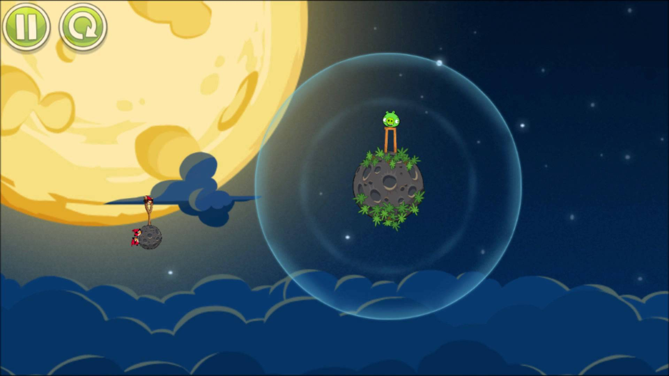  
     
   Given the above image, noting that the planet has a gravitational pull of 10 units/s/s towards its center but only when objects are within a radius of 20 units. Your physics-update rate is 1 frame per second.   
   **Initial State:** The bird is initially located at (0,0). The asteroid is at location (34,34).   
   Imagine you let go of the bird with an impulse force of (10,10). The bird has a mass of 2 units.

*For the following, show all calculations that will have to be done to correctly place the object at the proper locations using newton’s laws of physics: Frame 0 is the moment at which the mouse button is lifted. Also, you should think of the order in which you calculate the physics parameters, for each frame you should update the birds’ position last.*

* 1. [5 marks] Where would you draw the bird at **Frame 3** ?
  2. [5 marks] Where would you draw the bird at **Frame 4** ?
  3. [5 marks] Where would you draw the bird at **Frame 5** ?

1. [25 marks] **Collisions** 
   1. [5 marks] - and  are two circles.  has radius of 2 units and  has a radius of 5 units. If  is at location (2,3) and  is at location (4,5) show how you would test to see if they are colliding or not.
   2. [10 marks] - Describe **how** the separating axis test works and explain **why** it works, and **what** is the intuition behind the algorithm.
   3. [10 marks] - Given the following image, use the SAT algorithm to find a separating axis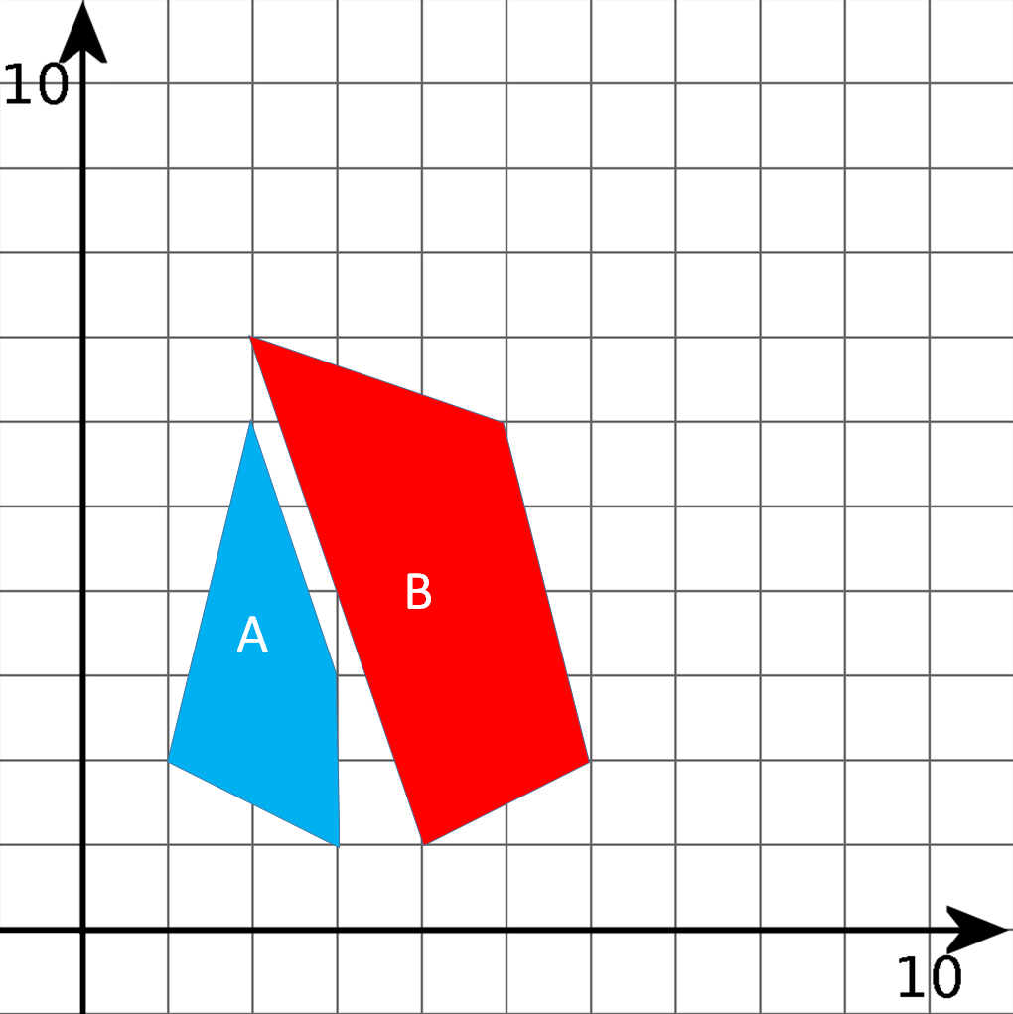

**Data Sheet.**   
Use the data on this sheet for ALL questions.

**Vectors**

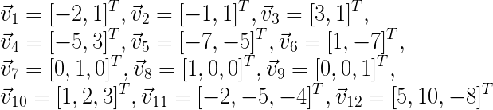

**Matrices**

